Design a FAN control board based on MAX31790 IC
Name :- Arnav Upate
Domain :- Electronics.
College :- YCCE, Nagpur
Dept. :- Electronics and Telecommunications
E-Mail :- 23070013@ycce.in

PCB Stack Up:-

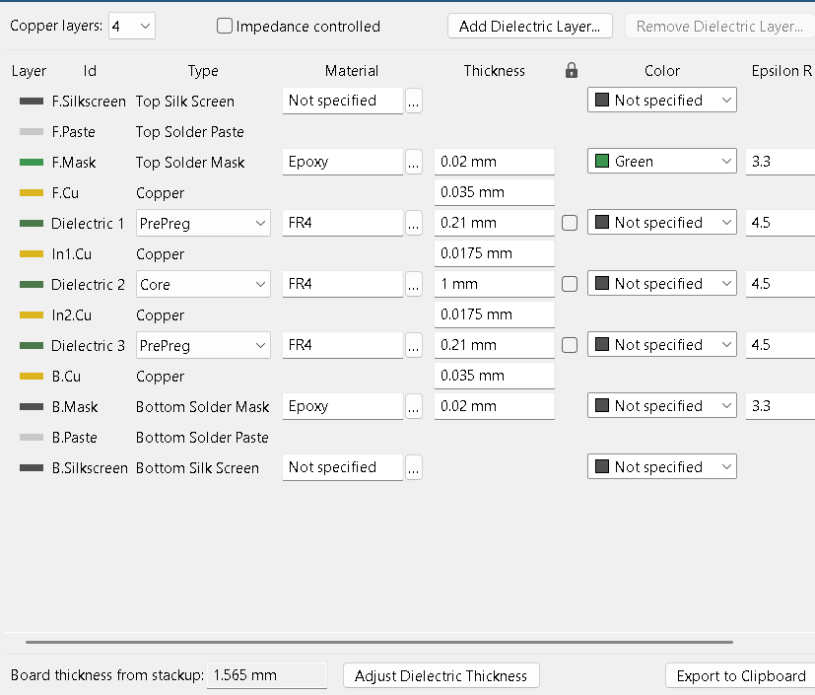

Traces:-
Power/Signal Rail | Track Width | Max Safe Current | Resistance (per 25.4mm) | Voltage Drop (per 25.4mm) | Power Loss (Heat)
Signal (PWM/Tach) | 0.20 mm | 1.28 A | 0.065Omega | 0.083V | 0.106W
3.3V Logic Rail | 0.60 mm | 2.80 A | 0.021Omega | 0.059 V | 0.165W
5V Controller Power | 1.00 mm | 4.01 A | 0.013 Omega | 0.052 V | 0.209 W
12V Fan Power | Copper Pour | 37.42 A | 0.000 | 0.0025V | 0.010 W

Design:-

Schematic:- 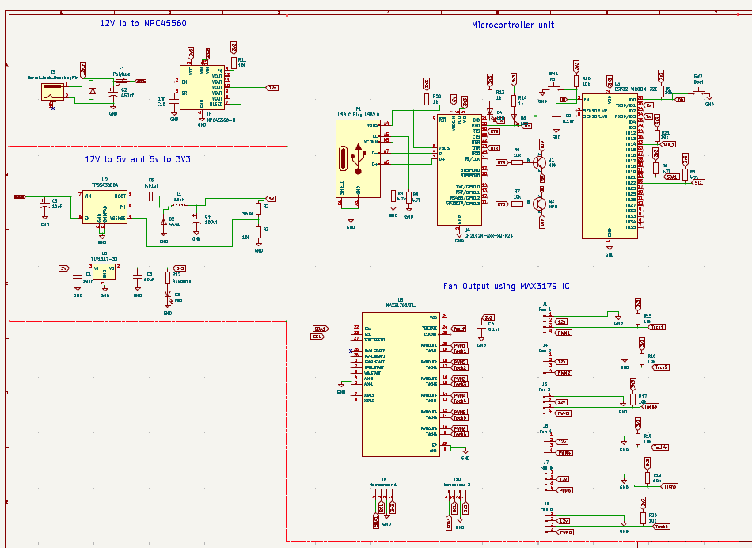
Board Bring Up:-
Primary Layer :-
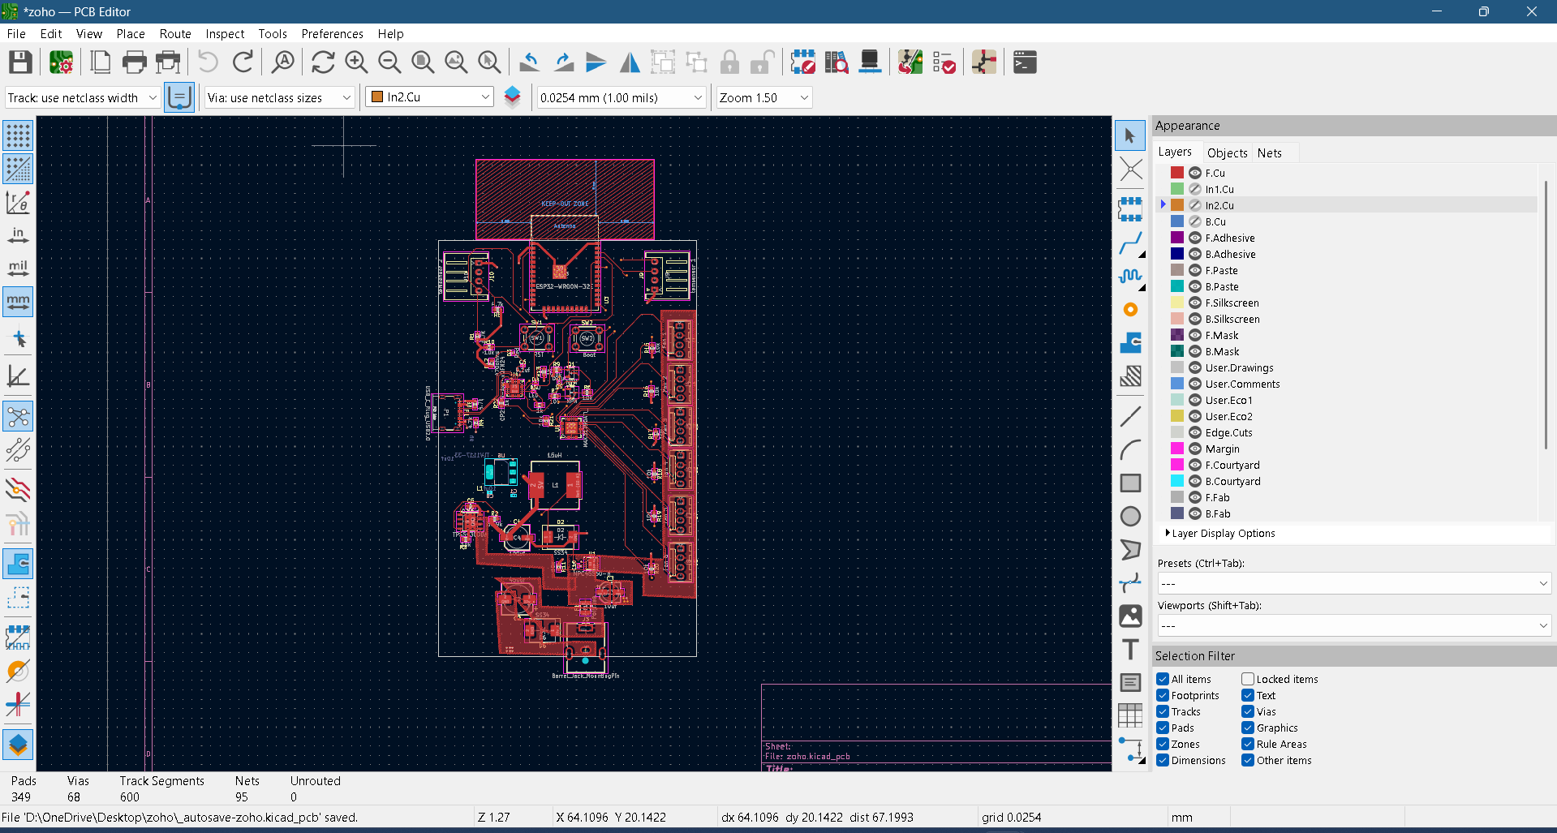

Inner Layer 1(Ground Plane):-
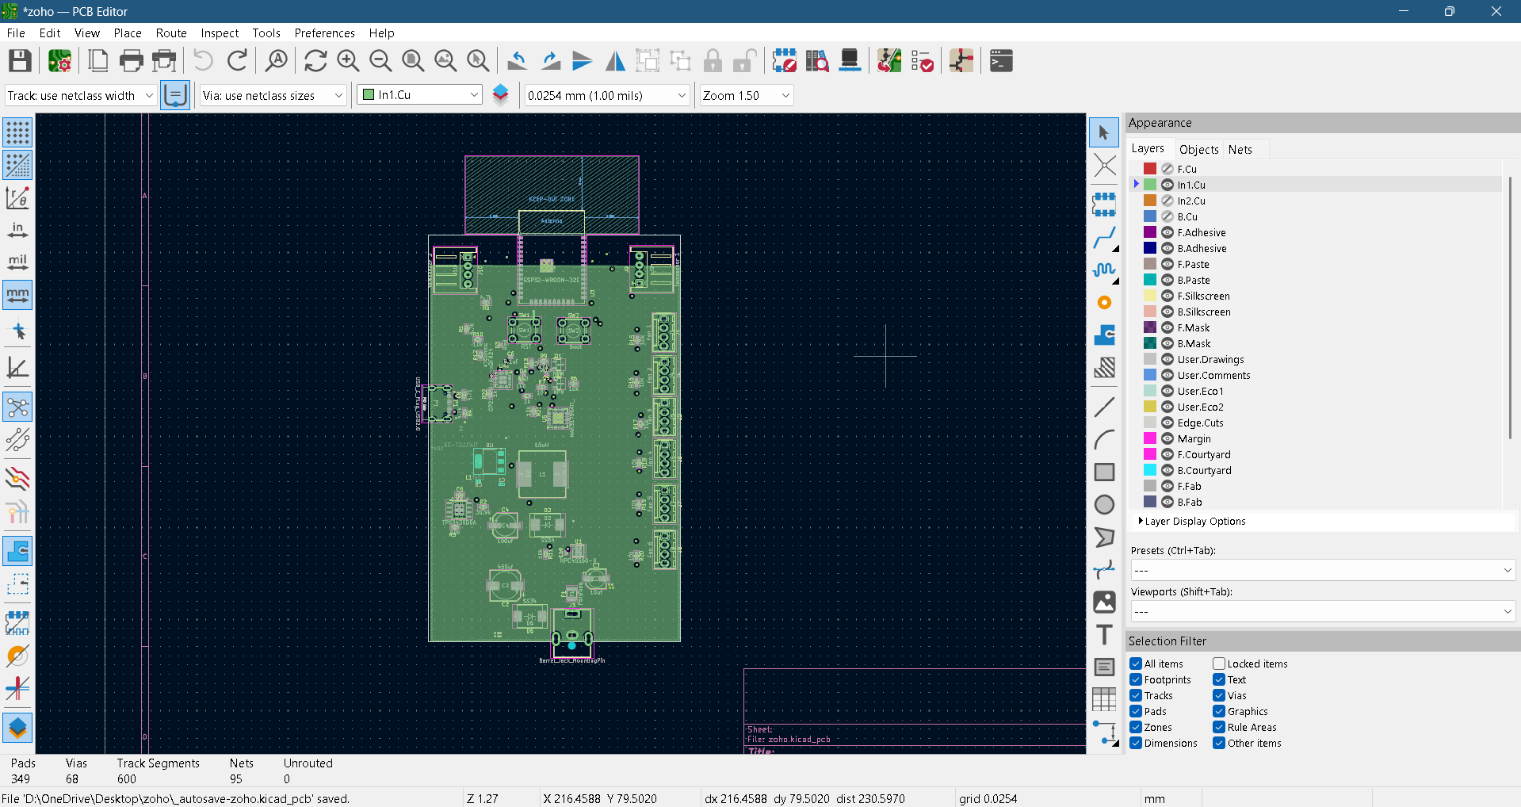

Inner Layer 2 (Power Plane):-
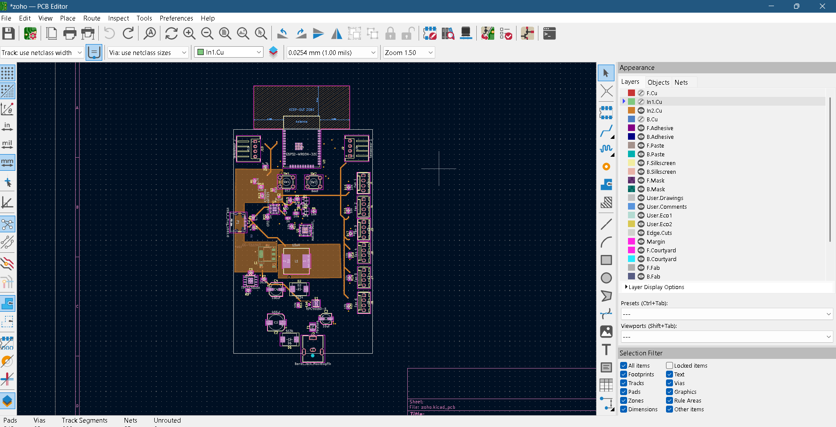

Bottom layer :-
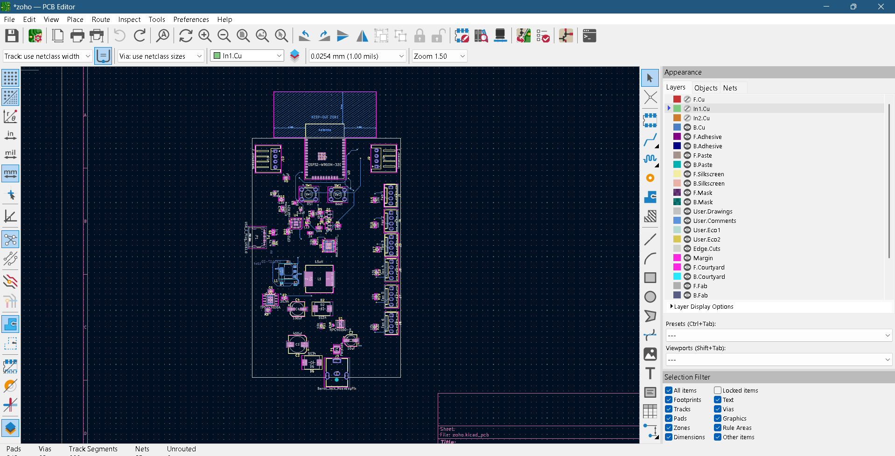
Close Up:-
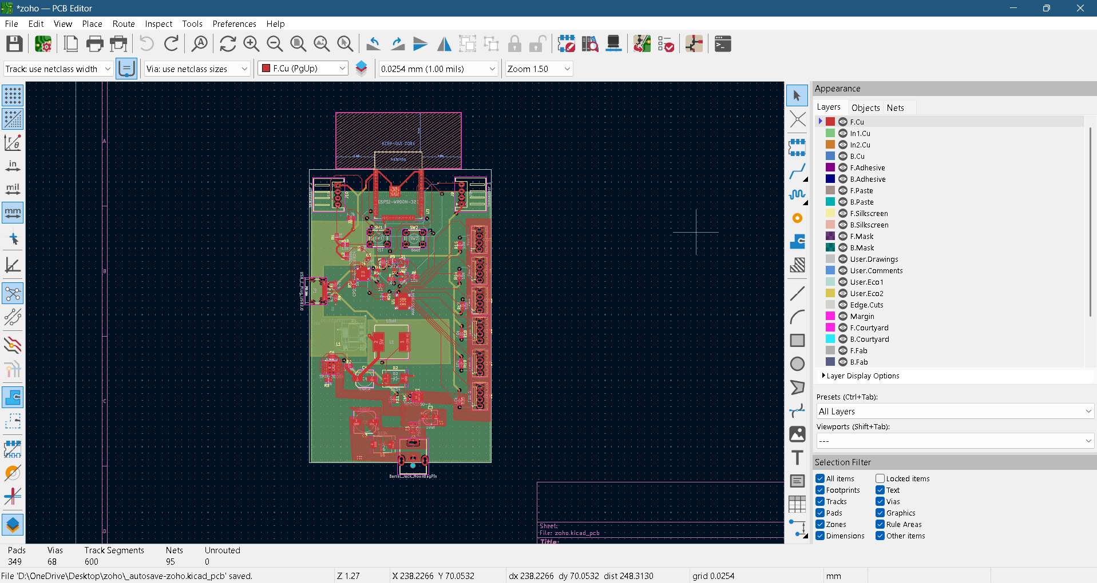
3D View:-
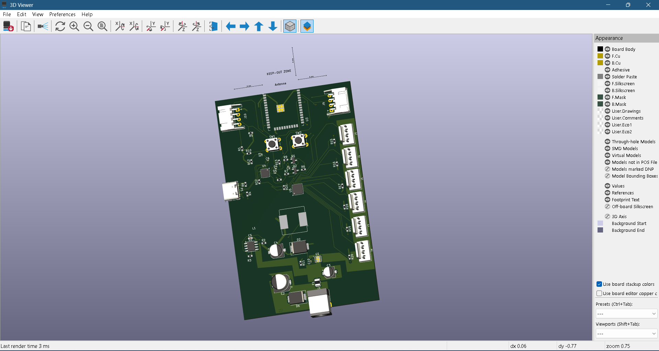
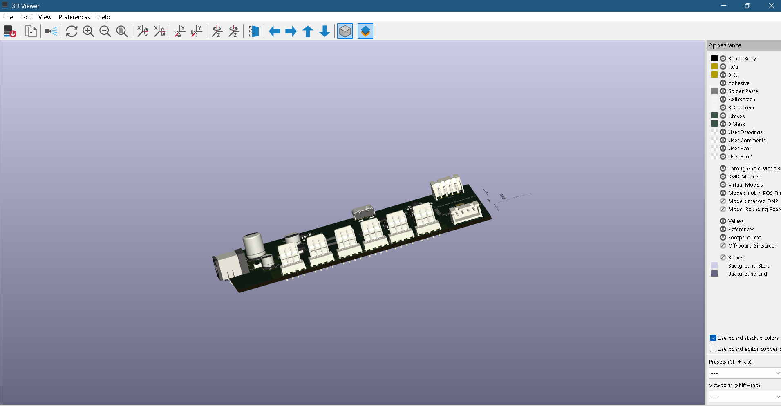
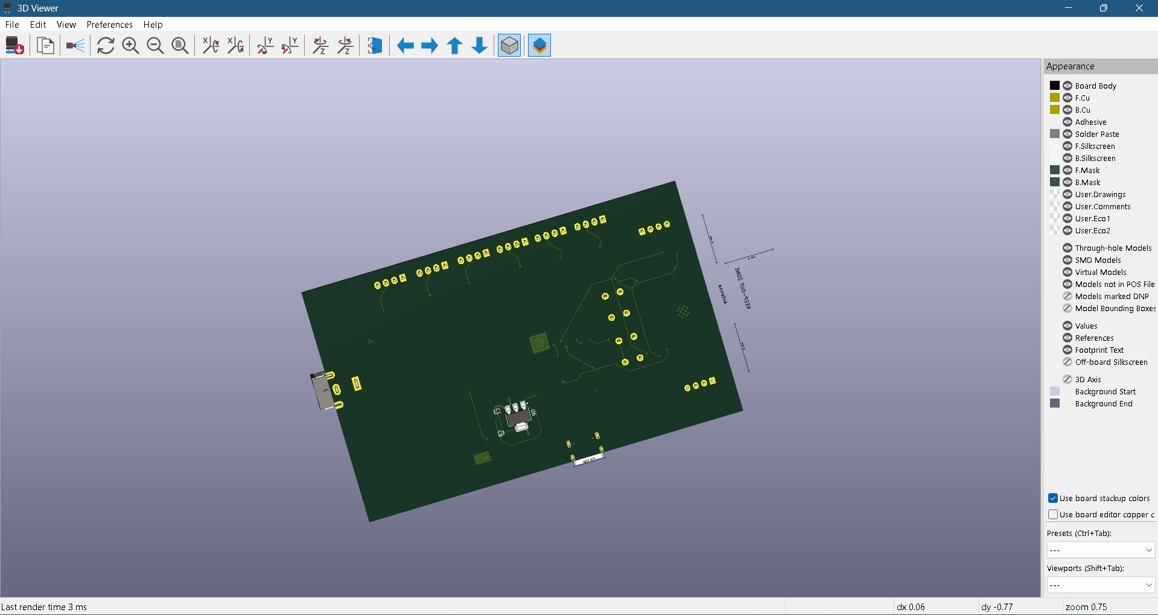
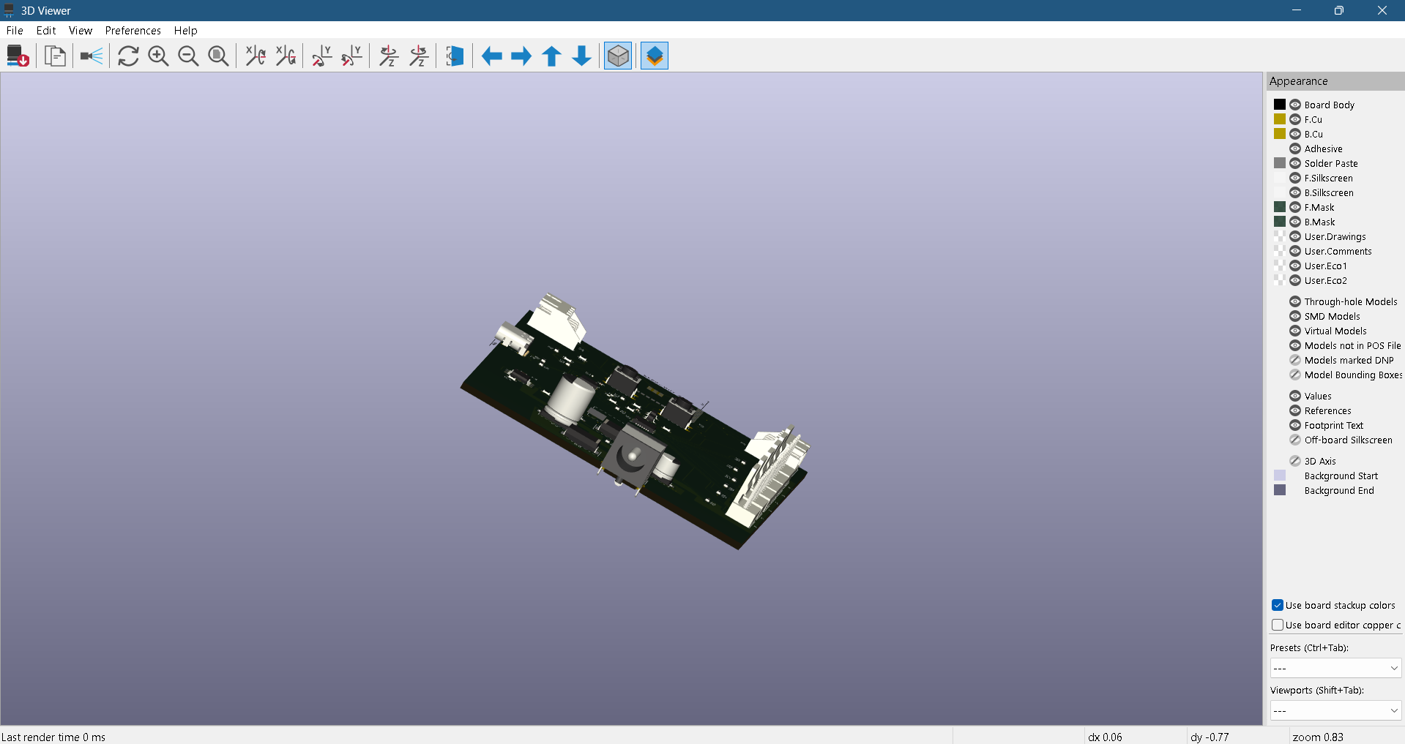

Simulation:- (PSpice Simulation)

Simulation is don’t for the power supply sources like 12v to 5v and 5v to 3v3 ,

1)12v to 5V:-
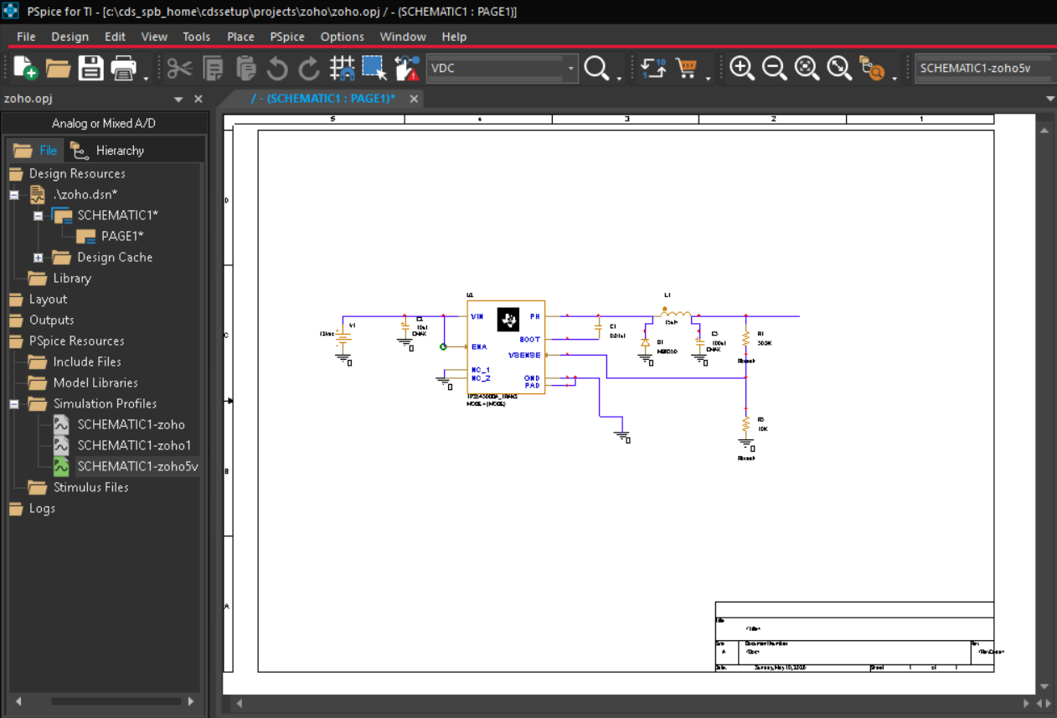
Outcome:- Gradually increasing to 5v on time duration of 10ms.
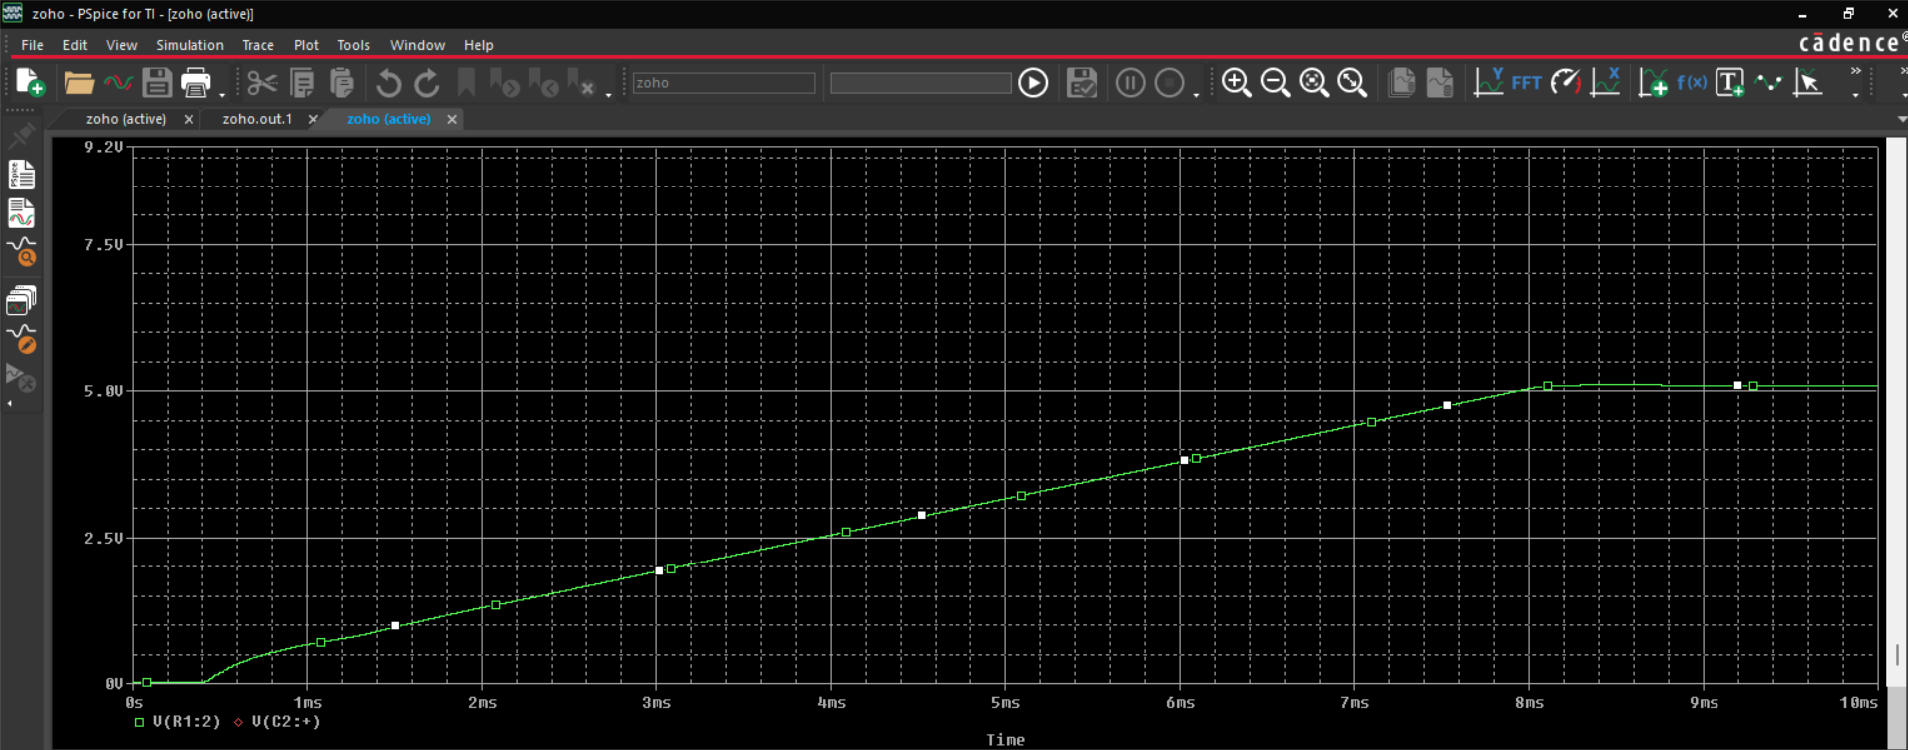

2) 5v to 3v3 :-
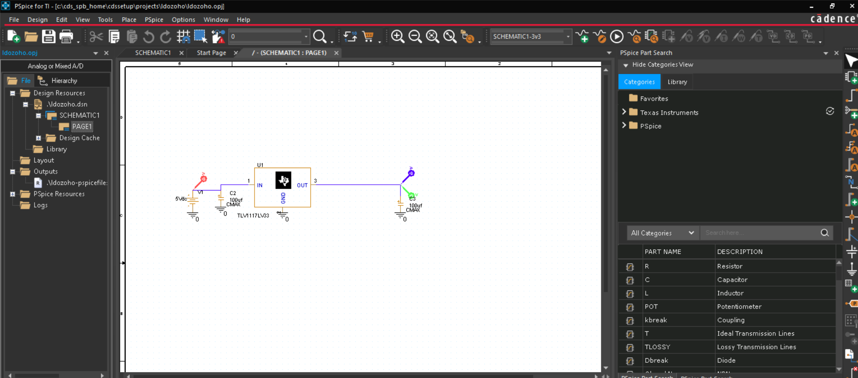
Outcome:-
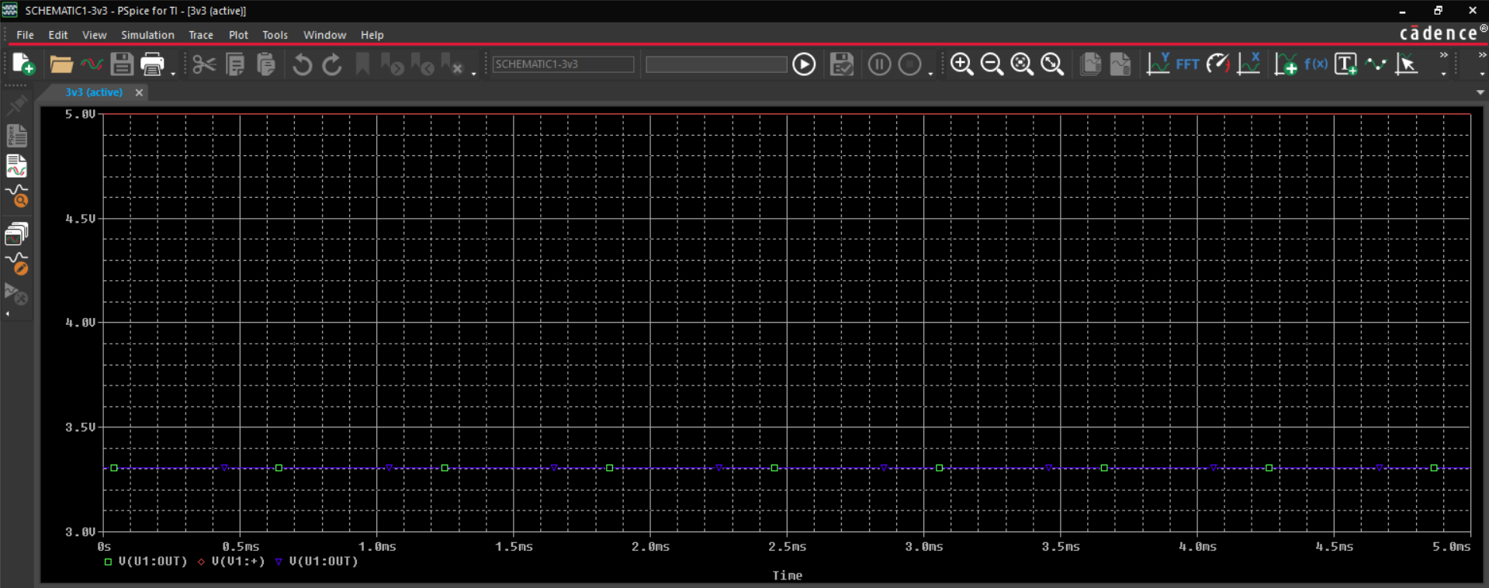
Scope of Improvement:-
• Better Via Parameters should be taken before designing the board.
• The connector placement should be better.

Conclusion:-
This project successfully achieved the complete hardware design, 4-layer stackup routing, and multi-physics simulation of an intelligent 6-server fan controller board. The physical layout parameters, plane zone boundaries, and drill sizes perfectly satisfy all low-cost fabrication constraints, confirming that the board is fully manufacturable.

References :-

1)TPS54560 Datasheet
2)TLV1117
3) PCB Way

